**Hands-On: Stage 3 - Angular SPA-012 to SPA-018 - Day 69 – Hands on 2**

**Session - 1**

1. **Angular Intro - Angular App Creation and Testing**

**app.component.ts**

import { Component } from '@angular/core';

@Component({

  selector: 'app-root',

  templateUrl: './app.component.html',

  styleUrls: ['./app.component.css']

})

export class AppComponent {

  title = 'angular-learning';

  public FavouriteMovie:string = "Lord of the Rings";

  public Titles:string = "Employee Details";

  public Id:number=1;

  public Name:string="John";

  public Salary:number=10000;

  public Permanent:boolean=true;

  public Department_Id:number=1;

  public Department_Name:string="payroll";

  public Skills:string[]=["Html","Css","JavaScripts"];

  public DateofBirth:Date=new Date('12/31/2000');

}

**app.component.html**

<h1>Hello World</h1>

<h3>{{FavouriteMovie}}</h3>

<br>

<div>

<h3>{{Titles}}</h3>

<!-- <app-employee></app-employee> -->

<strong>Id:</strong>{{Id}}<br><br>

<strong>Name:</strong>{{Name}}<br><br>

<strong>Salary:</strong>{{Salary}}

<br><br>

<span *ngIf="Permanent"><strong>Permanent:</strong>Yes</span>

<br><br>

<strong>Department Id:</strong>{{Department_Id}}

<br><br>

<strong>Department Name:</strong>{{Department_Name}}

<br><br>

<strong>Skills</strong>

<br><br>

<span><strong>Skill Id Skill Name</strong></span>

<ol type="1">

<li *ngFor="let item of Skills">{{item}}</li>

</ol>

<strong>Date Of Birth: </strong>{{DateofBirth}}

<br><br>

<!-- using pipes -->

<h1>Using Pipes</h1>

<strong>Id: </strong>{{Id}}<br><br>

<strong>Name: </strong>{{Name}}<br><br>

<strong>Salary: </strong>{{Salary | currency:"INR"}}

<br><br>

<span *ngIf="Permanent"><strong>Permanent:</strong>Yes</span>

<br><br>

<strong>Department Id: </strong>{{Department_Id}}

<br><br>

<strong>Department Name: </strong>{{Department_Name}}

<br><br>

<strong>Skills</strong>

<br><br>

<span><strong>Skill Id Skill Name</strong></span>

<ol type="1">

<li *ngFor="let item of Skills">{{item}}</li>

</ol>

<strong>Date Of Birth:</strong>{{DateofBirth | date}}

</div>

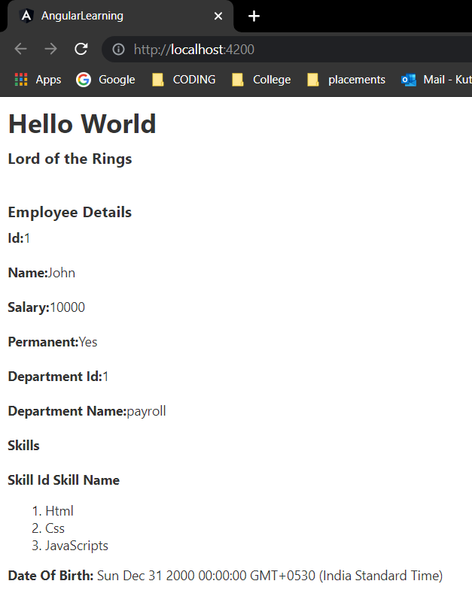**OUTPUT:**

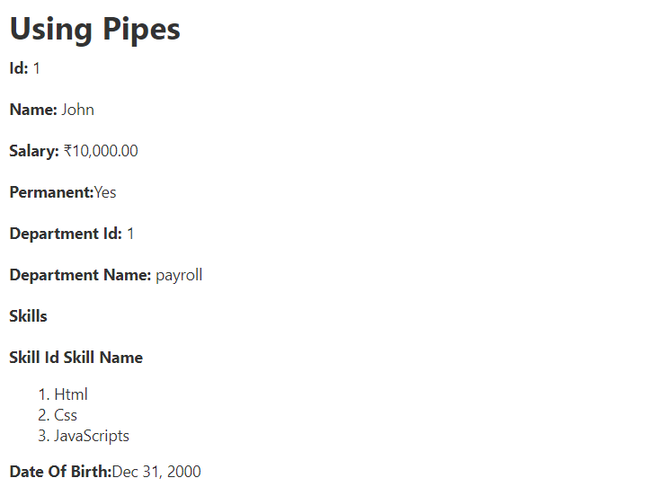

**Session - 2**

1. **Component and Routing – Create View Employee Component**

**app.module.ts**

import { NgModule } from '@angular/core';

import { BrowserModule } from '@angular/platform-browser';

import { AppRoutingModule } from './app-routing.module';

import { AppComponent } from './app.component';

import { ViewempsComponent } from './viewemps/viewemps.component';

import { EditempComponent } from './editemp/editemp.component';

import {Routes,RouterModule} from '@angular/router'

import { viewClassName } from '@angular/compiler';

import { QuantityIncrementComponent } from './quantity-increment/quantity-increment.component';

const appRoutes:Routes=[{path:"" , component:ViewempsComponent},

  {path:"EditEmployees" ,

  component:EditempComponent},{path:"QuantityIncrement",component:QuantityIncrementComponent}]

@NgModule({

  declarations: [

    AppComponent,

    ViewempsComponent,

    EditempComponent,

    QuantityIncrementComponent,

  ],

  imports: [

    BrowserModule,

    AppRoutingModule,

    RouterModule.forRoot(appRoutes)

  ],

  providers: [],

  bootstrap: [AppComponent]

})

export class AppModule { }

**app.component.ts**

import { Component } from '@angular/core';

@Component({

  selector: 'app-root',

  templateUrl: './app.component.html',

  styleUrls: ['./app.component.css']

})

export class AppComponent

{

}

**app.component.html**

<style>

  body { font-family: Segoe UI, Arial

}  a { text-decoration: none }

</style>

<h3>Angular Learning <br><a [routerLink]="['/']">View Employees</a> ||<a [routerLink]="['/EditEmployees']">Edit Employees</a>||

  <a [routerLink]="['QuantityIncrement']">Quantity Increment</a></h3>

<div>

<router-outlet></router-outlet>

**editemp.component.html**

<p>editemp works!</p>

**editemp.component.ts**

import { Component, OnInit } from '@angular/core';

@Component({

  selector: 'app-editemp',

  templateUrl: './editemp.component.html'

})

export class EditempComponent implements OnInit {

  constructor() { }

  ngOnInit(): void {

  }

}

**quantity-increment.component.html**

<p>Simple Button click Event!!</p>

<button (click)="firstbutton()">Click Me</button>

<br>

<br>

{{result}}

<br>

<input type="text" value={{num}}><button (click)="Add()">add</button>

<br>

<br>

<input type="submit" value="sub" (click)="sub1()" [disabled]="flag"><input type="text" value={{addandsub}}><input type="submit" value="add" (click)="add1()">

**quantity-increment.component.ts**

import { Component, OnInit } from '@angular/core';

@Component({

  selector: 'app-quantity-increment',

  templateUrl: './quantity-increment.component.html'

})

export class QuantityIncrementComponent {

  public result:string="";

  public firstbutton():void{

    this.result="click me button clicked";

  }

  public num:number=0;

  public Add():void{

    this.num++;

  }

  public addandsub:number=0;

  public flag:boolean=true;

  public add1():void{

    this.addandsub++;

    if(this.addandsub>0){

      this.flag=false;

    }

    else{

      this.flag=true;

    }

  }

  public sub1():void{

    this.addandsub--;

    if(this.addandsub>0){

      this.flag=false;

    }

    else{

      this.flag=true;

    }

  }

}

**viewemps.component.html**

<!-- using pipes -->

<strong>Id:</strong>{{Id}}<br><br>

<strong>Name:</strong>{{Name}}<br><br>

<strong>Salary:</strong>{{Salary | currency:"INR"}}

<br><br>

<span *ngIf="Permanent"><strong>Permanent:</strong>Yes</span>

<br><br>

<strong>Department Id:</strong>{{Department_Id}}

<br><br>

<strong>Department Name:</strong>{{Department_Name}}

<br><br>

<strong>Skills</strong>

<br><br>

<span><strong>Skill Id Skill Name</strong></span>

<ol type="1">

    <li *ngFor="let item of Skills">{{item}}</li>

</ol>

<br>

<br>

<strong>Date Of Birth:</strong>{{DateofBirth | date}}

**viewemps.component.ts**

import { Component, OnInit } from '@angular/core';

@Component({

  selector: 'app-viewemps',

  templateUrl: './viewemps.component.html'

})

export class ViewempsComponent {

  public Id:number=1;

  public Name:string="John";

  public Salary:number=10000;

  public Permanent:boolean=true;

  public Department_Id:number=1;

  public Department_Name:string="payroll";

  public Skills:string[]=["Html","Css","JavaScripts"];

  public DateofBirth:Date=new Date('12/31/2000');

}

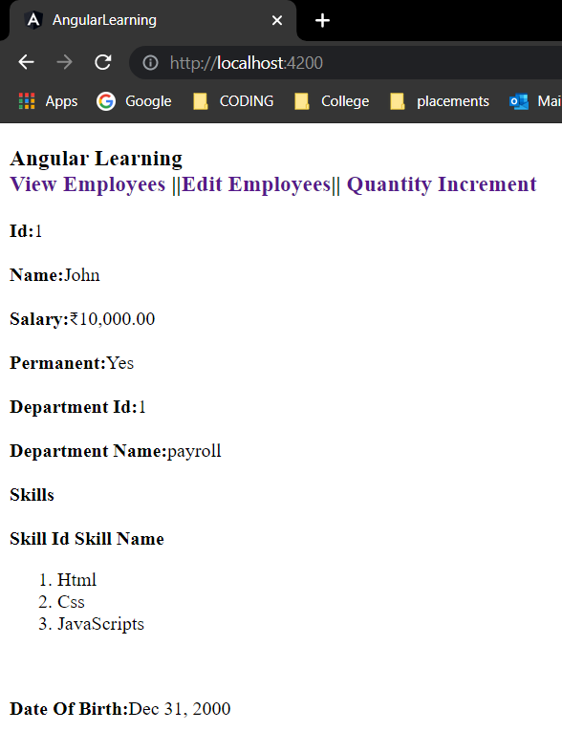**OUTPUT:**

